# Blah blah

Blah blah ILEMT

Carnegie Mellon University

Blah blah

Cameron N. Riviere, Ph.D.

Final Progress Report

# A. Specific Aims

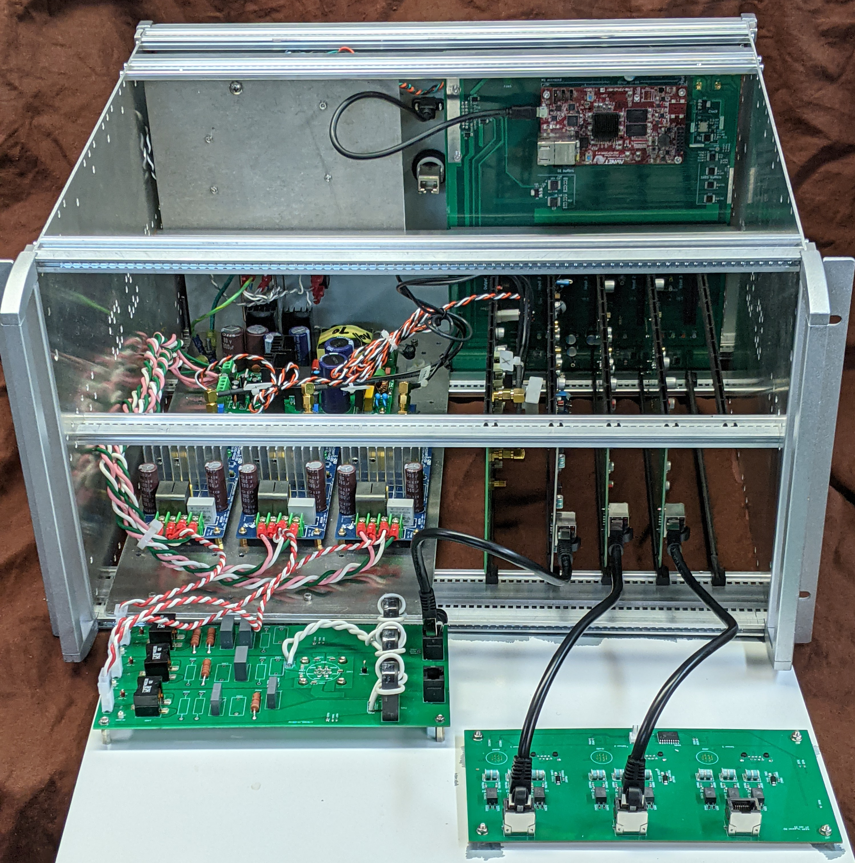

Figure 1: Reference design electronics

1. Develop a real-time tracker reference design
2. Algorithms for interference rejection
3. Validation of EMT performance specifications
4. Evaluate tracking reliability during surgery *in vivo* and in cadavers

# B. Studies and Results

## Performance (Aims 1, 3)

As Table 1 shows we did achieve or surpass the proposed performance for almost all the key metrics. The only shortcoming is that it was not possible to evaluate the measurement latency because the real-time pose solution was not implemented. Achieving low noise together with high bandwidth was the primary technical challenge and rationale for the design. It was necessary to choose a higher sample rate in order to achieve the desired 500 Hz bandwidth.

Table 1

|  |  |  |  |
| --- | --- | --- | --- |
|  | **Proposed** | **Achieved** | NDI Aurora™ |
| Bandwidth (Hz) | 500 | 500 | 20 |
| Samples/second | 1000 | 1500 | 40 |
| Latency (ms) | 1.5 | (real-time not implemented) | 14 |
| Noise (µm RMS, 1-Hz bandwidth) | 0.15 | 0.15 | 140 |
| Figure of merit $)$ | 150 | 150 | 0.031 |
| Accuracy (µm RMS) | <400 (or 1% of motion) | 208 (0.32% of motion) | 600 |
| Workspace (mm/°) | >200 mm / any | >200 mm / any | 500 mm / any |
| with sensor size (mm, $\sqrt[3]{volume}$) | 15mm | 15mm | 3 mm |

Notably, the achieved accuracy is much better than proposed. The precise match for the noise and sensor size is a coincidence since the final implementation is considerably different than that discussed in the proposal. The NDI Aurora tracker performance is shown for comparison. This is the most common EMT used in operating rooms but is far slower and also less accurate than ILEMT.

## Reference design (Aim 1)

We designed and implemented the open hardware *reference design*, Fig. 1. Our aim is to not only prove the usefulness of ILEMT, but also to make the technology freely available. The reference design consists of complete details including software, electronic CAD files, component lists, calibration source code and design files calibration fixtures. By combining open design and software-defined architecture, the reference design is a flexible platform for future research, and a valuable component of larger systems such as handheld robots and microsurgical simulators. This design is freely available under Apache License 2.0 on osf.io, <https://osf.io/6fwjk/>.

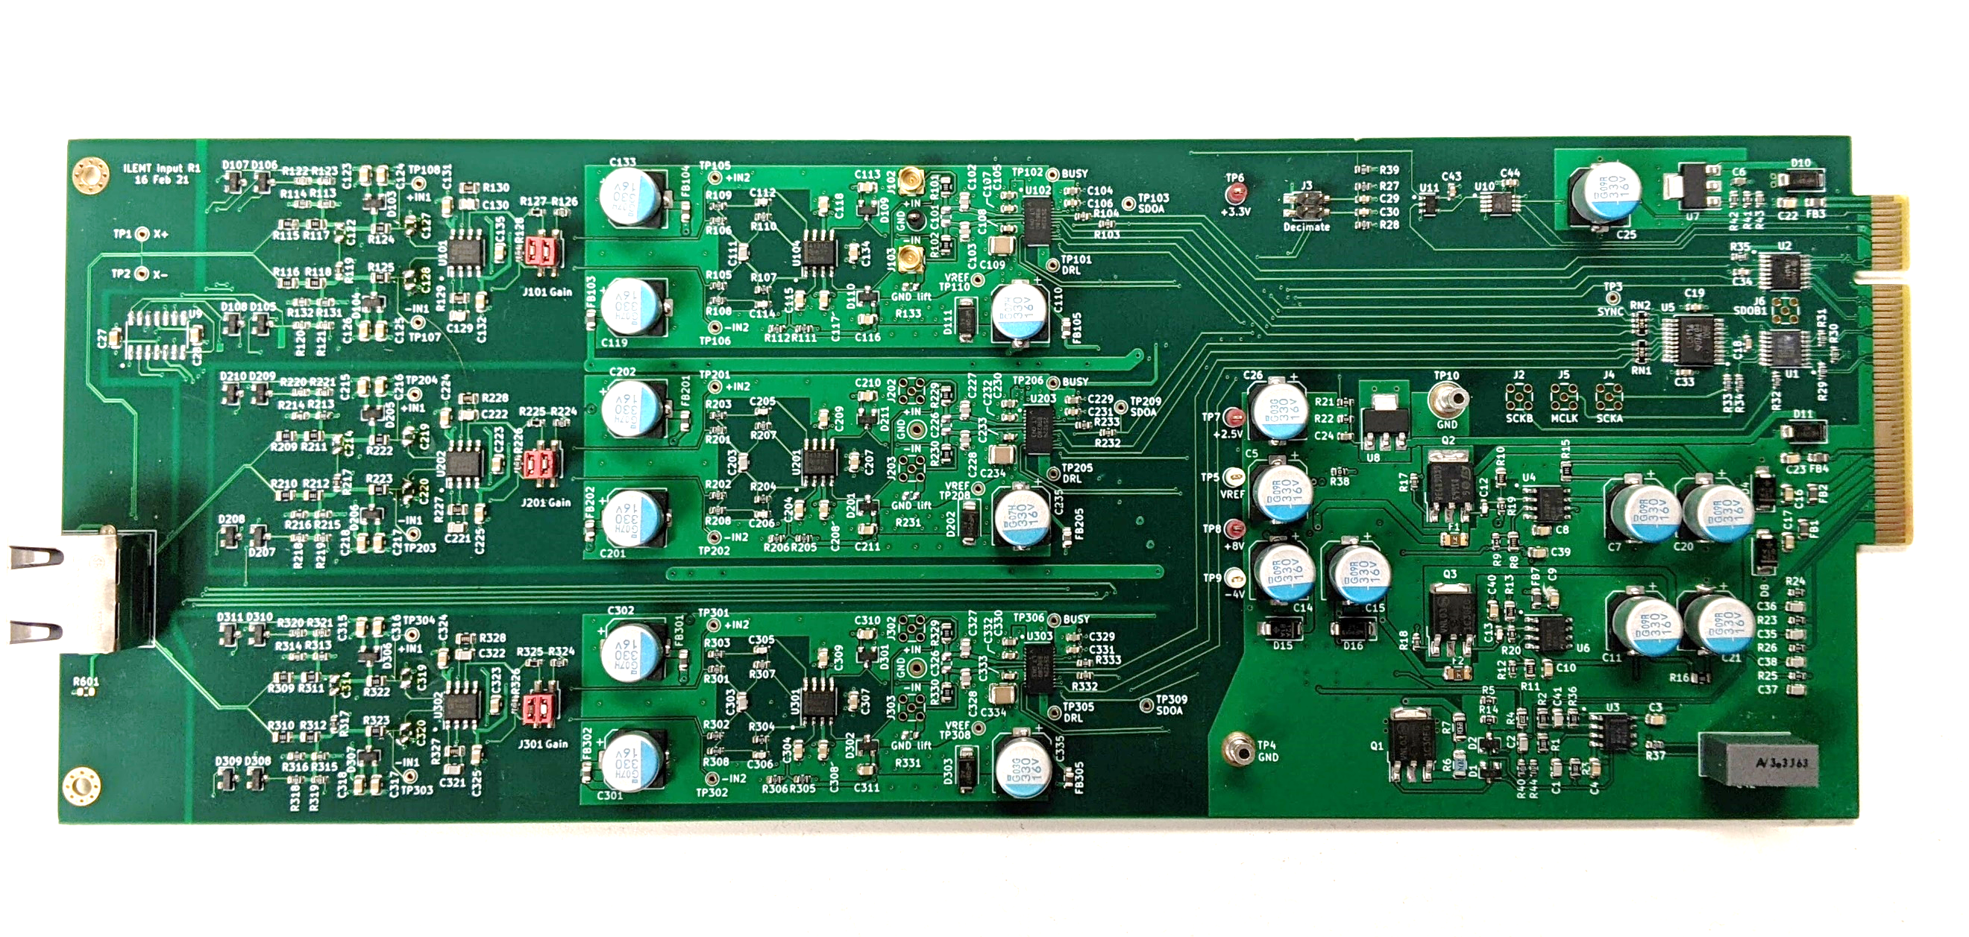

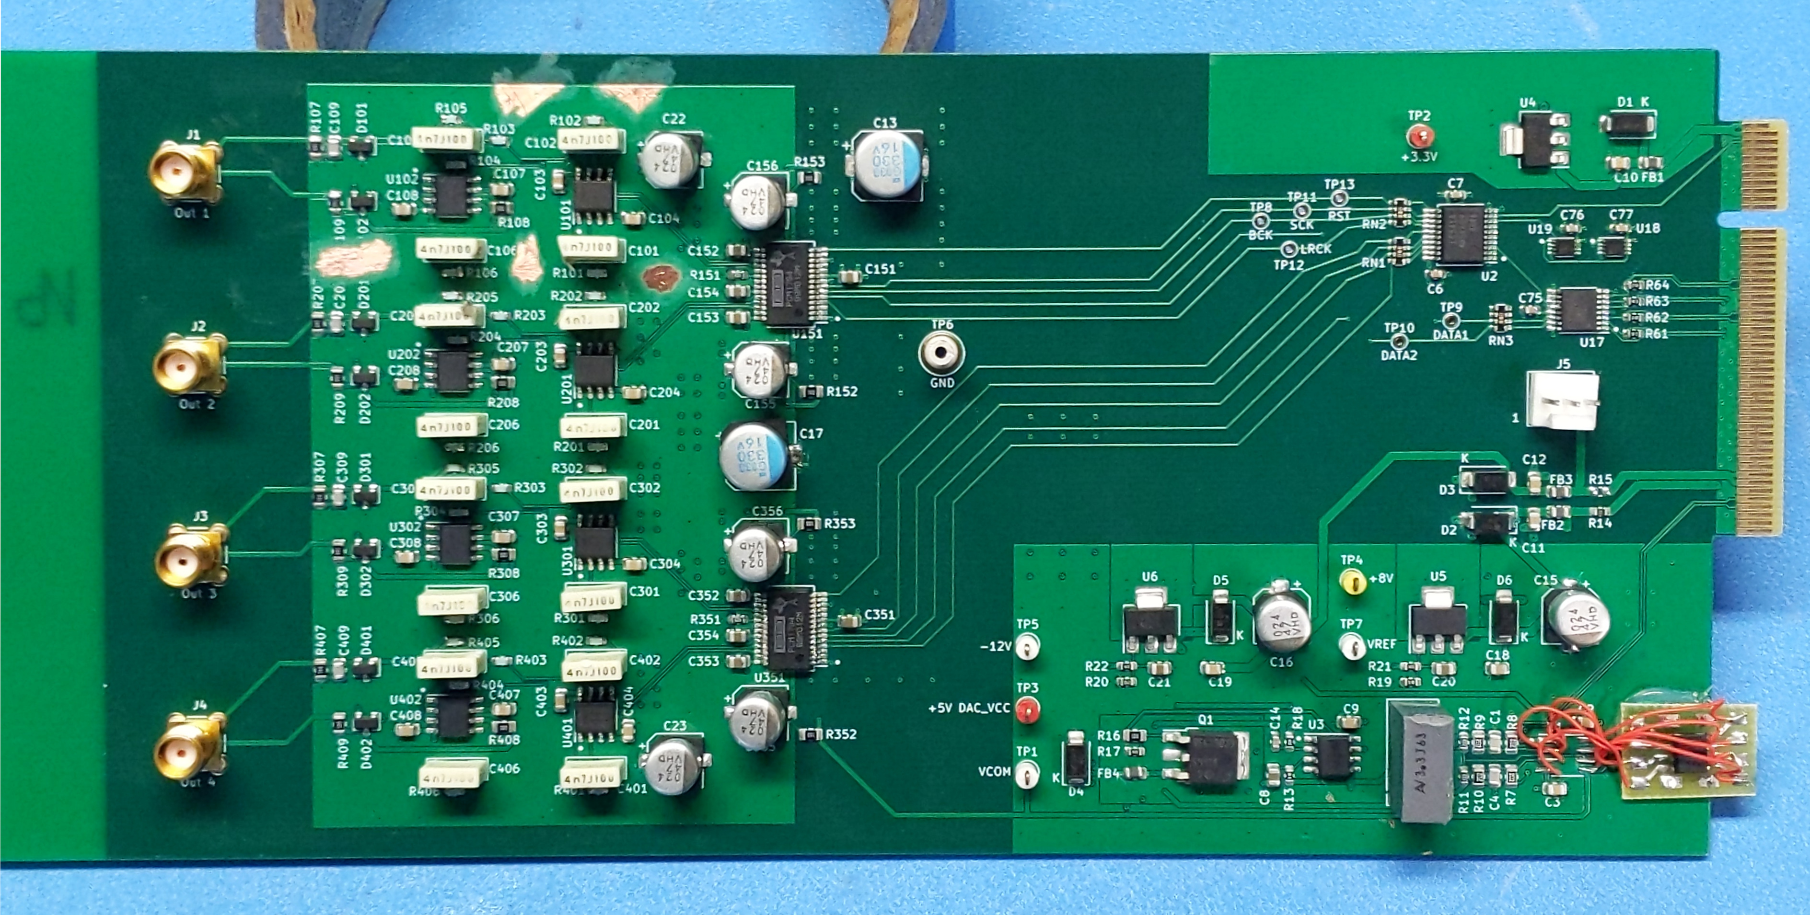

Figure 2: Input and output boards

Attainment of the desired noise performance is primarily due to the low noise and wide dynamic range design of the analog input and output boards (Figure 2). The input board is quite critical for realizing the position noise performance of the tracker system. The requirement is not so much for low noise (though that is needed), but very wide dynamic range. Specifically, the measured noise must be very low even in the presence of a near full scale signal. The analog to digital conversion usually adds some noise that is proportional to the signal level, causing the noise floor to rise at larger signal levels. Two major causes of this noise rise are clock jitter and reference noise. Particular ADC designs and architectures may also contribute. We evaluated some digital audio interfaces and audio ADCs using sigma-delta ADCs, but found considerable noise rise. We ended up using an oversampling SAR converter (LTC2512-24) which, as implemented, does not show any noise floor rise.

This ADC has a differential input, giving 10V PP input swing with the 5V reference. This improves the dynamic range, but also requires a differential driver. Since the sensor input is differential it worked well to use a fully differential design for the low noise amplifier and antialias filter/driver. This helps reduce cross coupling between the input channels. Low noise analog supplies are generated locally on the card from the reference voltage. These use a high speed opamp and a discrete pass device to give a very low output impedance in the ~10 kHz range where the tracker operates, minimizing cross-coupling between channels.

One challenge was low-noise distribution of a single shared reference voltage to all the converters on all the input boards. A shared reference is very desirable because it cancels the effect of drift and low frequency noise. The conversion cycle draws current spikes from the reference, but the reference must still remain clean as seen from the other ADCs. We use only a single reference buffer per board with LC decoupling between the ADCs. This buffer has a differential input from the master reference, a lowpass filter, and a low impedance output buffer.

The output board has very low noise audio DACs (PCM1794A) giving an output noise well below that of the input noise of the class-D output drivers. The high 10V peak-to-peak output of the DAC allows the output driver gain to be reduced, reducing referred noise. These DACs were not designed to use an external reference, but we discovered how to deliver a reference derived from the main board reference through the DAC reference bypass pin. This greatly reduces 1/f noise in the reference, which would otherwise be multiplied with the carrier signal causing 1/f noise in the demodulated signal amplitude.

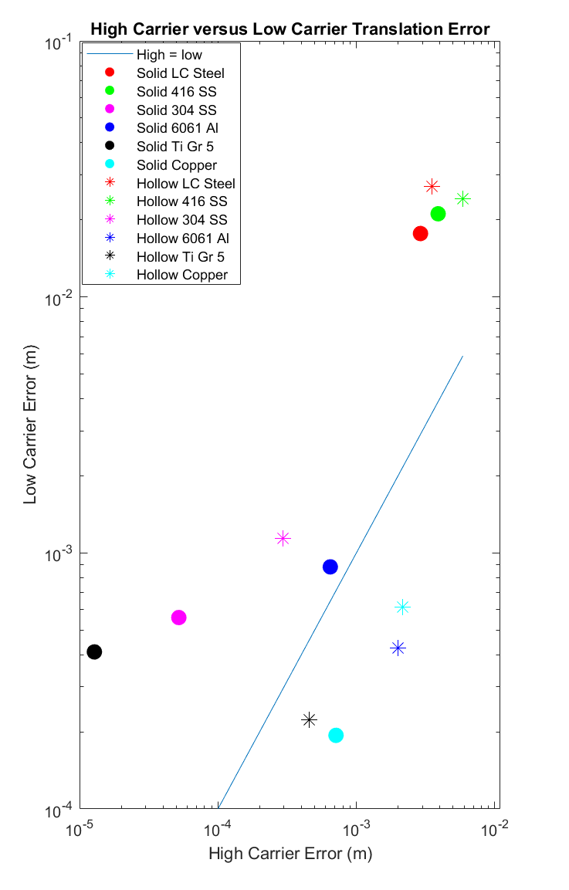

Figure 3: High/low carrier errors

The hardware goals have been met, but real-time software and documentation are still largely missing. The high sample rate gives a large computational demand, which we proposed to meet in part by use of digital processing in the FPGA, but converting processing algorithms from Labview and Matlab into FPGA code is a considerable engineering effort. We developed preliminary C++ code for real-time pose estimation, but the speed was still not quite high enough for real-time operation, so further algorithm refinement and low-level tuning is needed.

## Interference rejection (Aim 2)

The proposed Kalman demodulator (Maclachlan et al., 2017) does suppress impulse noise quite well, but when demodulating six or more channels the Labview signal processing was not able to keep up, so this method can’t be used until the real-time software has been completed. Another kind of interference is cross coupling between the source channels, which degrades accuracy, since the pose solution assumes that each source channel emits only the desired carrier, but due primarily to mutual inductance between the source coils some off-axis signal does appear. We developed an adaptive algorithm which senses the off-axis signals in the source current and adjusts the DAC output to cancel it out. This was important to enabling the high position accuracy achieved.

A major concern for EM trackers has been metallic interference, where the presence of metal in or near the workspace causes a disturbance in the measurement. The reference design hardware does successfully implement the proposed *Dual path high/low modulation*, but we have so far only made preliminary investigations into the effect of different metals (Figure 3) and did not go beyond the preliminary approach of assuming that the low carrier measurement is correct, which effectively compensates the error of high conductivity metals such as aluminum. There is definitely useful information which remains to be exploited.

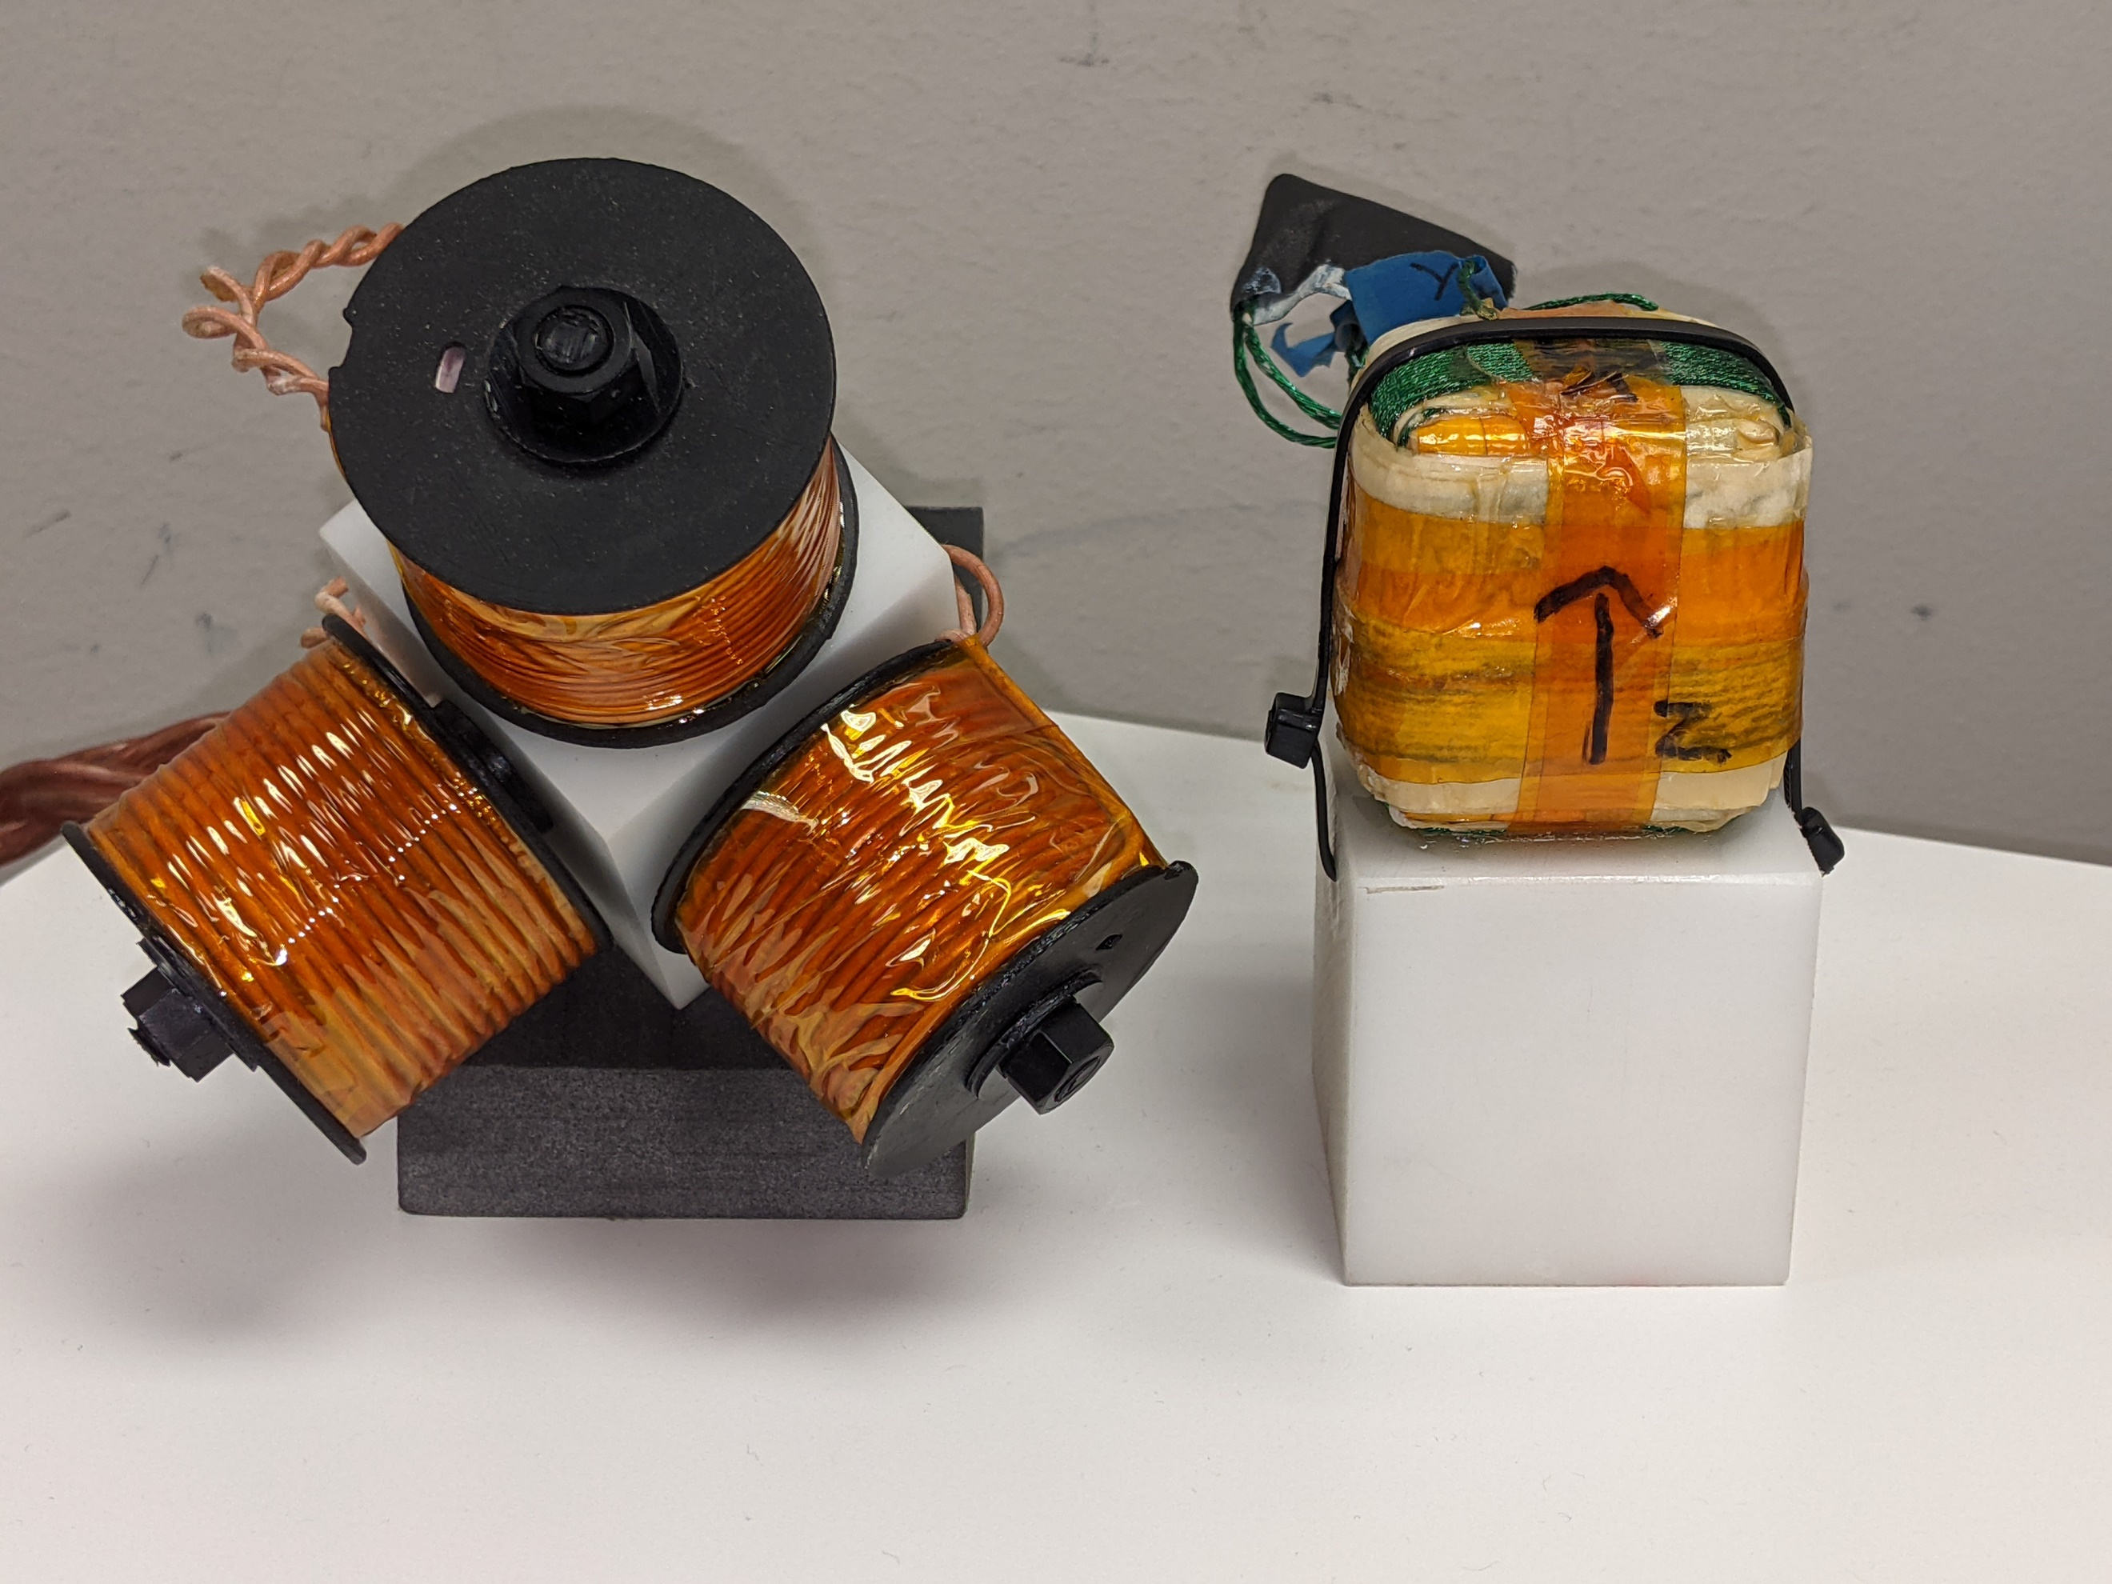

Figure 3: Dipole and concentric source designs.

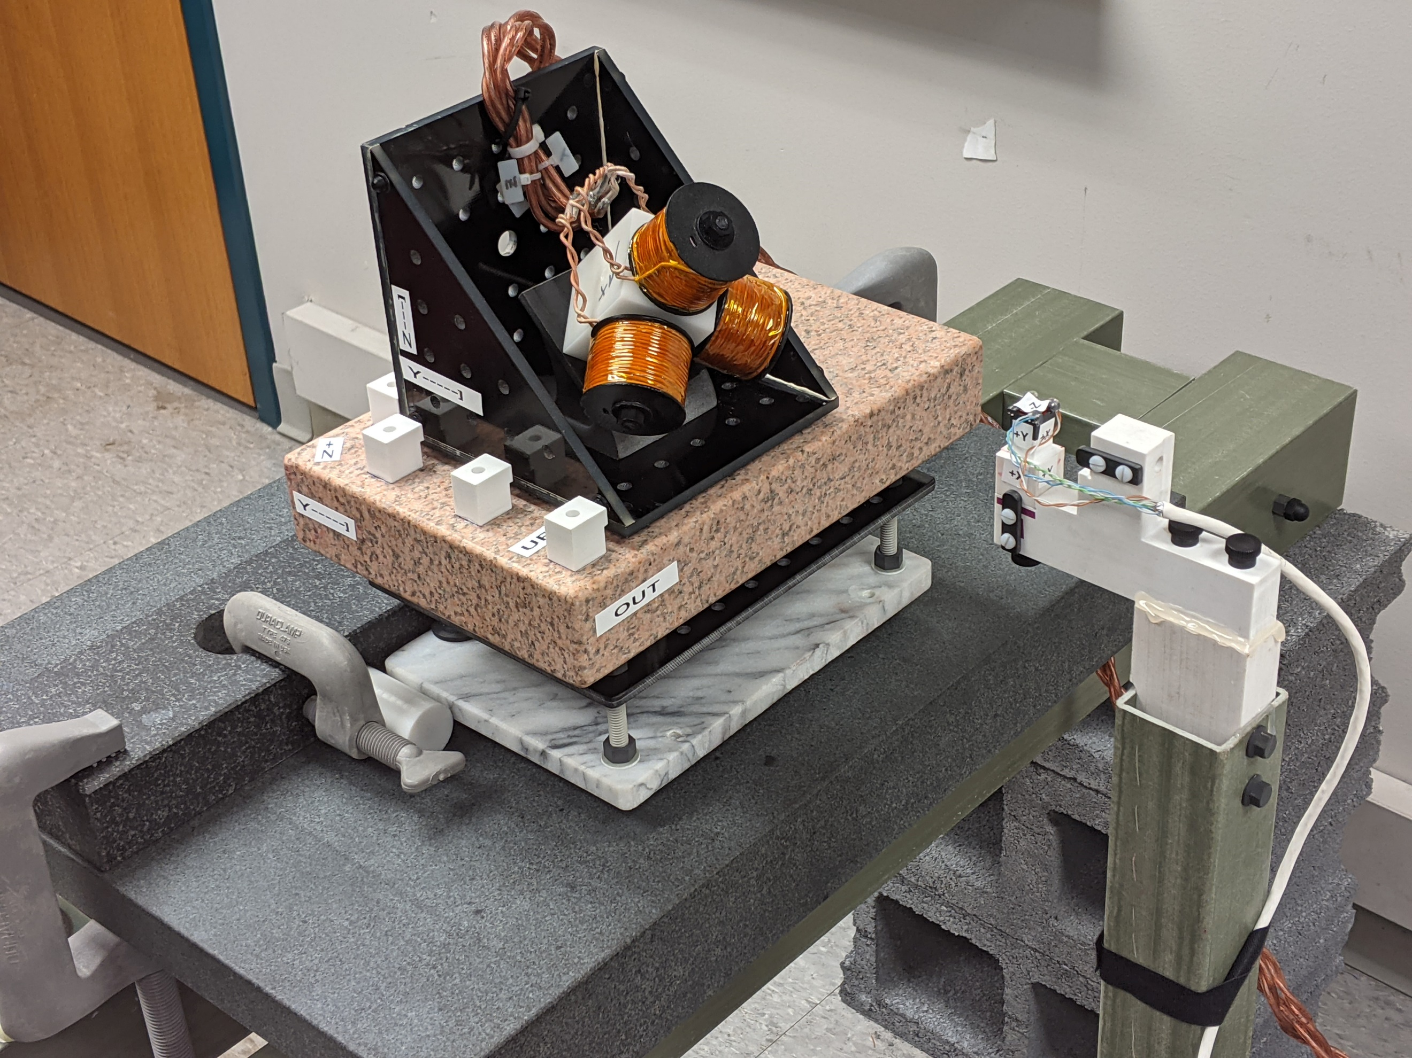

Figure 3: Calibration stage

## Calibration and validation of accuracy (Aim 3)

Calibration was high successful (Table 1), surpassing the accuracy of commercial products, which we only expected to match. We constructed a non-metallic *calibration stage* (Figure 3), as proposed, but ended up using manual fixtures to supply additional rotations of the source and sensor because it proved difficult to construct actuated axes that were both non-metallic and sufficiently accurate. We implemented open-source calibration software that supports a wide variety of source and sensor geometries and comes with scripts which enable reproducible calibration and accuracy testing. Table 2 shows the measured position and orientation errors for two different source designs and three calibration methods. The proposed *dipole approximating* source gives the best accuracy, while the *concentric* source design enables a much more efficient pose solution algorithm at the cost of reduced accuracy (Kim et al., 2018).

Table 2

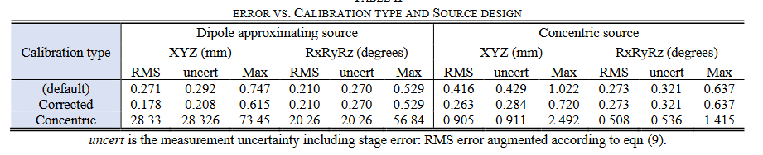s

## In-vivo experiments (Aim 4)

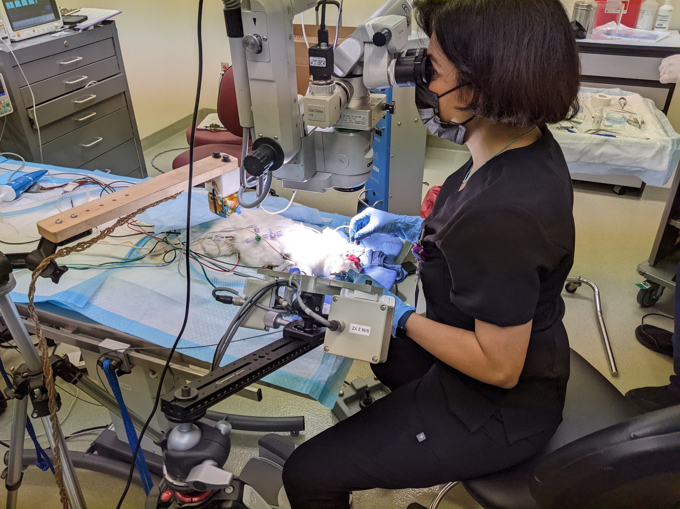

Figure 4: Rabbit experiments

We conducted two experiments where the ILEMT tracker and the ASAP optical tracker were both used to measure instrument motion during rabbit vitrectomy surgery. This enables the comparison of the reliability of the optical and magnetic tracker types, what interference is experienced, and how often the optical tracker loses track due to sightline requirements. This data has not been completely analyzed, but optical tracking was frequently lost during the experiment, requiring readjustment of the optical tracker head. The much larger ILEMT workspace and insensitivity to sightlines eliminated this difficulty.

# References

Kim, W., Song, J., & Park, F. C. (2018). Closed-Form Position and Orientation Estimation for a Three-Axis Electromagnetic Tracking System. *IEEE Transactions on Industrial Electronics*, *65*(5), 4331–4337. https://doi.org/10.1109/TIE.2017.2760244

Maclachlan, R. A. A., Hollis, R. L. L., Jaramaz, B., Riviere, C. N. N., Martel, J. N. N., Urish, K. L. L., & Riviere, C. N. N. (2017). *Multirate Kalman filter rejects impulse noise in frequency-domain-multiplexed tracker measurements*. *2017-Decem*, submitted. https://doi.org/10.1109/ICSENS.2017.8234073